San-Culottes

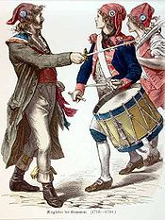

Urban workers and peasants, whose name: literally, “without culottes,” the knee breeches that the privileged wore, signified their wish to distinguish themselves from the high classes. The mob mentality of the sans-culottes constituted the most radical element of the Revolution.
The appellation sans-culottes refers to their lower class status; culottes were the fashionable silk knee-breeches of the nobility and bourgeoisie, as distinguished from the working class sans-culottes, who traditionally wore pantalons, or trousers, instead. The sans-culottes, most of them peasants and urban labourers, served as the driving popular force behind the revolution. Though ill equipped, they also made up the bulk of the Revolutionary army during the early years of the French Revolutionary Wars.

