King Louis XVI
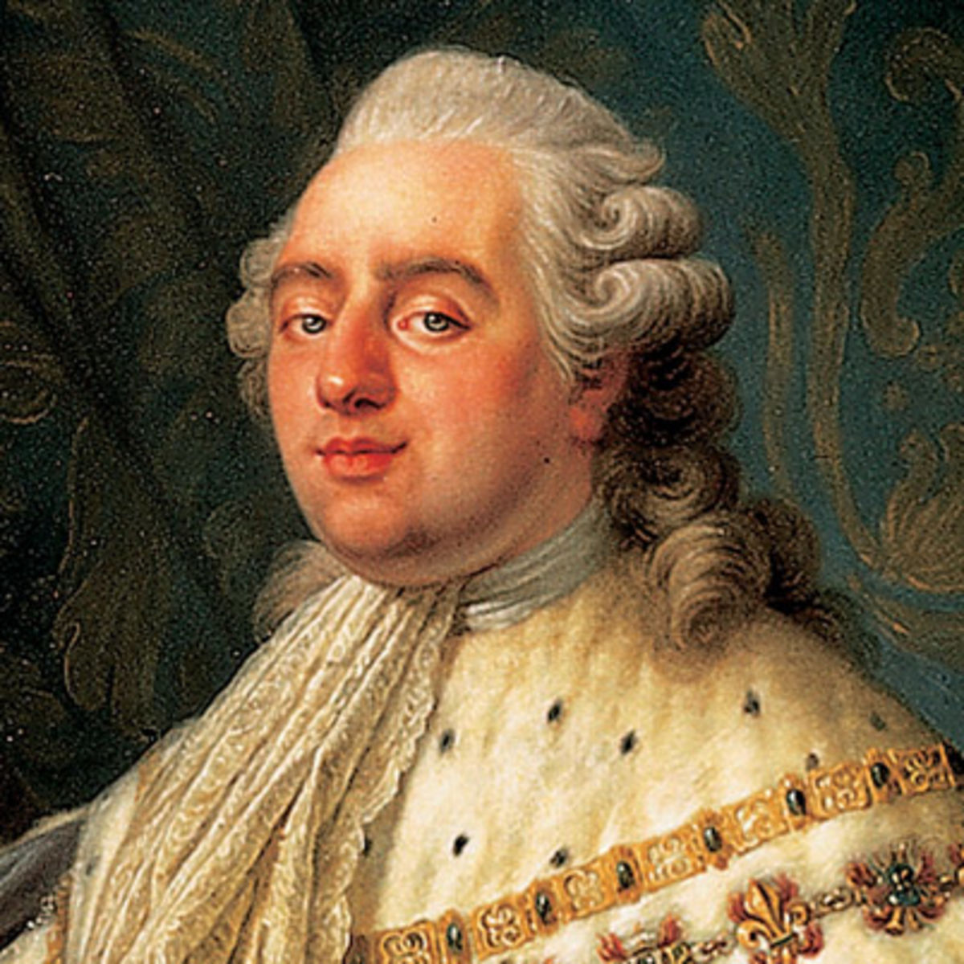

The French king from 1774 to 1792 who was deposed during the French Revolution and executed in 1793. Louis XVI inherited the debt problem left by his grandfather,Louis XV, and added to the crisis himself through heavy spending during France’s involvement in the American Revolution from 1775 to 1783. Because this massive debt overwhelmed all of his financial consultants, Louis XVI was forced to give in to the demands of the Parlement of Paris and convene the Estates-General—an action that led directly to the outbreak of the Revolution. Louis XVI was deposed in 1792 and executed a year later.
http://www.history.com/topics/louis-xiv

http://www.bbc.co.uk/history/historic_figures/louis_xvi.shtml

http://thereignofterror-frenchrev.weebly.com/king-louis-xvi.html

http://www.history.com/this-day-in-history/king-louis-xvi-executed

http://www.biography.com/people/louis-xvi-9386943

