The Jacobin Club

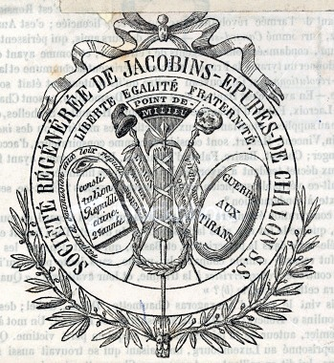

The Jacobin Club, also known as the Society of the Friends of the Constitution, was the most famous and influential political club in the development of the French Revolution. Initially founded by anti-Royalist deputies from Brittany, the Club grew into a nationwide republican movement. The Jacobin Club included both prominent parliamentary factions of the early 1790s, the radical 'Mountain' and the more moderate 'Girondists'.

Led by Maximilien Robespierre, the Jacobins called for democratic solutions to Frances problems and spoke for the urban poor and French peasantry. The Jacobins took control of the convention and France from 1793 to 1794. Robespierre was concerned with counterrevolutionary threats and therefore insisted a brutal period of public executions. The Girondists dominated the Jacobin club in 1792-93. The Girondists called for an aggressive foreign policy and forced war on Austria. They were the dominant faction when the Jacobins overthrew the monarchy and created the republic. When the Republic failed to deliver the unrealistic gains that had been expected, they lost popularity. The National Guard eventually switched its support from the Girondists to the Mountain.
In May 1793, led by Robespierre, the leaders of the Mountain faction succeeded the Girondist faction and controlled the government until July 1794. Their time in government was branded by radical reformist legislation imposed with very high levels of political violence. In June 1793, they approved the Constitution of Year 1 which introduced universal male suffrage for the first time in history. In September 1793, twenty-one prominent Girondists were guillotined, beginning the Reign of Terror. In October, during the Terror, the new constitution was ratified in a referendum which most eligible voters avoided participating in. The Mountain executed tens of thousands of opponents nationwide.
In 1794, the Fall of Robespierre pushed the Mountain out of power. The Jacobin Club was closed and many of its remaining leaders, including Robespierre, were executed.

