The Girondins

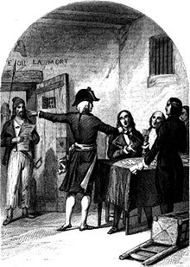
A French political group founded October 1st 1791 within the legislative assembly and national convention.
The Liberal political group dissolved October 24th, 1794

The Girondins was the name given to the moderates in the National Convention. The Girondins controlled the legislative assembly until 1793, when, with the war going poorly and food shortages hurting French peasants, the Jacobins ousted them from power.
The Girondists proposed suspending the king and summoning of the National Convention; but they had agreed not to overthrow the monarchy until Louis XVI had become impervious to their counsels. Once the republic was established, they were anxious to stop the revolutionary movement which they had helped to set in motion.. The Girondists, who had been the radicals of the Legislative Assembly (1791–1792), became the conservatives of the Convention (1792–1795).

A group including some Girondists prepared a draft constitution, known as the Girondin constitutional project, which was presented to the National Convention in early 1793. Thomas Paine was one of the signers of this proposal.

On the 31st of October 1793, Revolutionary Tribunal executes 21 Girondin deputies who have not gone into hiding. Jean-Marie Roland had escaped, but his wife, Manon Roland, is executed a week later as part of the purge. The verdict was a foregone conclusion. They were borne to the guillotine. It took 36 minutes to cut off 22 heads

