Georges Danton
Born 26th October 1759
Died 5th April 794

Georges Danton was the first president of the committee of public safety.
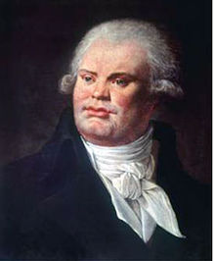

Georges Danton was a leading political figure throughout the Reign of Terror. He was a moderating influence on the Jacobins Club.

Danton was a member of the National Convention, which ruled France until 1795. His role was minister of Justice.

Georges Danton was a revolutionist who followed the ‘Mountain’ Faction of the Jacobin Club. His successor was Maximilien Robespierre.

On April 5th, 1794, Danton was executed by Guillotine. He was accused of leniency to the enemies of the Revolution.

