Emmanuel-Joseph Sieyès

Born: 3rd May 1748

Died: 20th June 1836

Emmanuel Sieyes was an Author, clergyman and politician
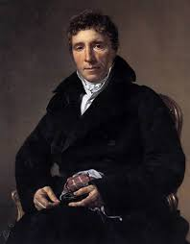

French churchman and constitutional theorist who because he was not of noble birth, could not advance in the clergy. He was embittered towards the aristocracy and in January 1789 Sieyès issued his pamphlet “What Is the Third Estate?, in which he identified the unprivileged Third Estate with the French nation and asserted that it alone had the right to draft a new constitution where the third estate had more power as they were the majority. (Britannica, 2015)

Emmanuel Sieyes was A liberal member of the clergy, supporter of the Third Estate, and author of the fiery 1789 pamphlet “What Is the Third Estate?” Sieyès was one of the primary leaders of the Third Estate’s effort at political and economic reform in France.

